What is Habitat Destruction?

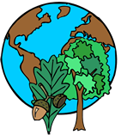A habitat is the natural home for an animal or plant. Habitat destruction is when an animal or plant loses its natural home, usually caused by something humans have done. If an animal’s habitat gets destroyed, it might die out. If this happens, it can affect all animals above it on the [food chain](http://library.thinkquest.org/08aug/00473/foodchain.html).

Habitat destruction is one of the main threats to biodiversity. Biodiversity refers to the various kinds of plants and animals that live in a particular area. Arctic communities have less biodiversity because of the very few species of animals that live there. Tropical forests, however, have thousands of different animal and plant species, making them the most biodiverse areas on earth. Ecologists use biodiversity as a way of measuring how habitats are affected by land use.

All species need specific food and a specific habitat to survive. The more specific these needs, the greater the risk to the species if their habitat changes or is lost.

**What are the Causes of Habitat Destruction?**

We humans are a major cause of habitat destruction. While animal populations do not usually rise sharply, the number of human beings on our planet has risen steeply in the last few centuries. This huge increase is putting pressure on natural resources. Our needs are growing, and these needs are often causing habitat destruction.  Here are some major causes of habitat destruction:

**Logging**    
People are cutting down the forests and rain forests for wood and wood products.   
Usually, only large prime trees are cut down, such as mahogany. However, smaller trees can be destroyed in the process and never replaced. Logging can cause soil erosion, and the logging roads that are built can damage rivers and streams.

For most of the world’s poor people, wood is the only source of fuel they have. Eighty percent of all wood used worldwide is for fuel. Collecting wood for fuel does not necessarily destroy rain forests, but it does damage or degrade them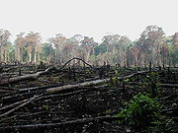.

Agriculture  
Wild lands are being cleared for crops and domestic animals. The single biggest cause of deforestation is farming. Animals used to living in a biodiverse habitat cannot survive in an area with one crop.

Building Roads and Cities  
Humans are clearing trees and wild lands to make room for roads and cities. Cities replace the natural habitat of many species of plants and animals. Highways and freeways can destroy plants and also keep animals from safely traveling through their natural habitat.

**Forest Fires**Forest fires destroy or damage between 15 and 36 million acres of tropical forest every year. Sometimes the fires are started on purpose as a way to illegally clear an area of trees.

**Where is it Happening?**

Habitat destruction is happening all over the world and closer to your home than you might think. Tropical rain forests in Central and South America and in Southeast Asia and Oceania are being threatened. Rainforests now occupy less then ½ of the land that they did 100 years ago (that’s less than 2% of the earth’s surface).

Borneo is one of the most biodiverse places on earth. There are many different kinds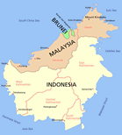 of animals on Borneo including sun bears, clouded leopards, gibbons, eight different species of monkeys, around 1,000 elephants, rhinos and orangutans. However, the orangutan population has fallen 50% in the last 50 years. The number of rhinos has fallen to less than 50 rhinos.

One of the main threats to Borneo’s biodiversity is the loss of lowland forests. In the past two decades, people have cleared about two million acres of these forests. The lowland forests are being cleared to make room for palm oil plantations. Many animals cannot survive on just one crop.

Around the world natural wetlands are disappearing. The U.S. has lost half its wetlands in the last 200 years. Europe has lost two-thirds of its wetlands in the last 300 years.

Tourism is hurting the natural habitats of animals dependent on mountains, coral reefs and beaches. An example is the green turtle that uses the island beaches in the South Atlantic Ocean to lay its eggs.

Near Milwaukee, Wisconsin, United States, a Boy Scout troop planted one thousand milkweed plants to replace the ones bulldozed for a basin detention project. Each year, thousands of monarch butterflies stop and eat the milkweed on their way south for the winter.

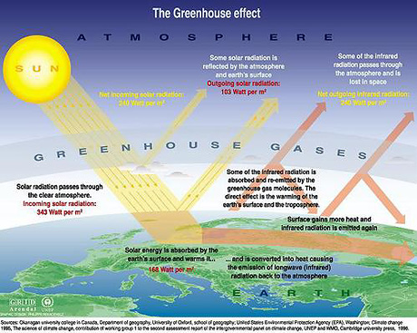

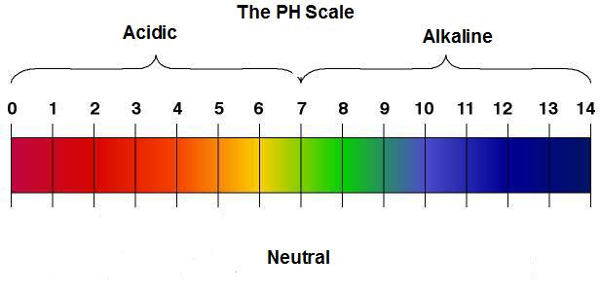

**Basic**

**Measuring Acid Rain**

Acid rain is measured using a scale called “pH.” The lower a substance's pH, the more acidic it is. See the [pH page](http://www.epa.gov/acidrain/measure/ph.html) for more information.

Pure water has a pH of 7.0. However, normal rain is slightly acidic because carbon dioxide (CO2) dissolves into it forming weak carbonic acid, giving the resulting mixture a pH of approximately 5.6 at typical atmospheric concentrations of CO2. As of 2000, the most acidic rain falling in the U.S. has a pH of about 4.3.

Two networks, both supported by EPA, monitor acid rain’s pH and the chemicals that cause acid rain. The [National Atmospheric Deposition Program](http://nadp.sws.uiuc.edu/) measures wet deposition and developed maps of rainfall pH (follow the link to the isopleth maps) and other important precipitation chemistry measurements.

The [Clean Air Status and Trends Network (CASTNET)](http://www.epa.gov/castnet/) measures dry deposition. This EPA Web site features information about the data collected, the measuring sites, and the types of equipment used.

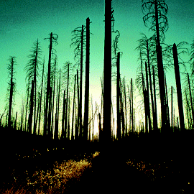

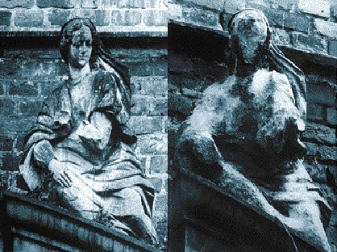

Before Acid Rain After Acid Rain

**Global Warming:**



Information for overfishing station can be found at the following website:

http://overfishing.org/pages/what_can_I_do_to_help.php